Note: Only 1 virtual switch defined;

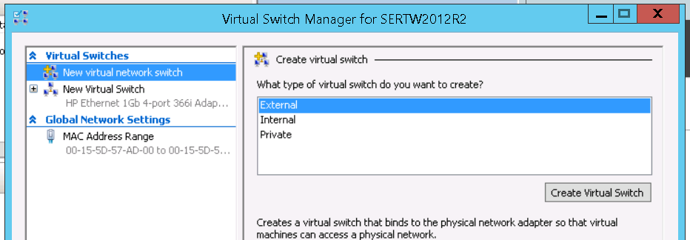

Start VSP installation;

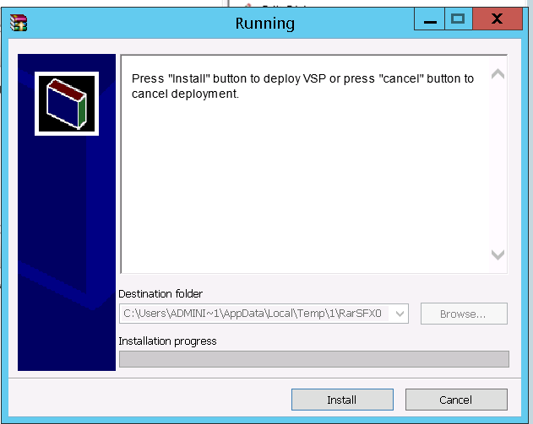

It will fail;

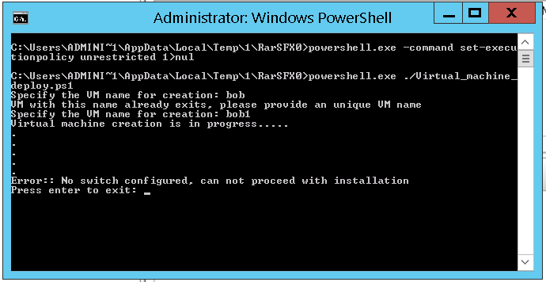

So at this point simply copy the Vhd files necessary for the VSP. The “1” folder in the “Temp” dir may differ, also the username of the user performing the install may vary depending on your particular situation. I did this under “Administrator”. They should be copied to a location specified by the customer, the default folder they have specified in the Hyper-V setup. For the purposes of this example I copied them to the desktop.

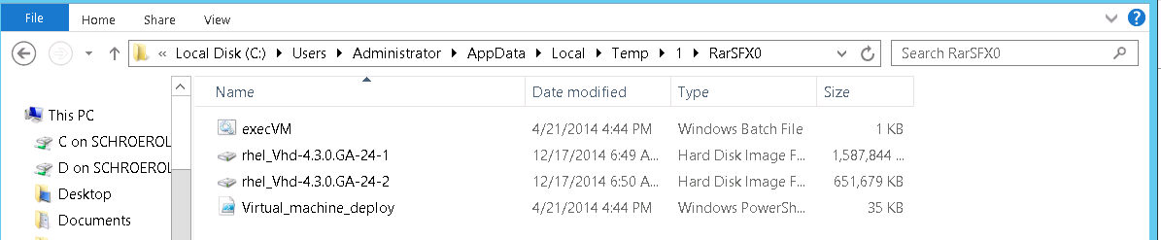

At this point, exit from the installer. We need to create a new Virtual Machine using Hyper-V manager.

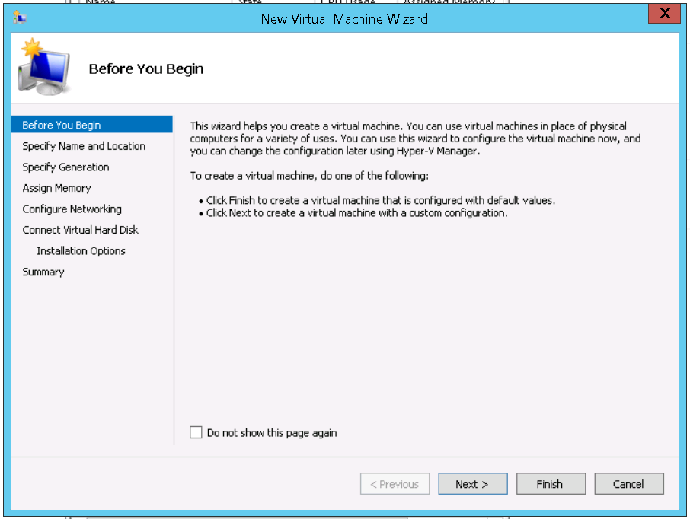

Provide the name:

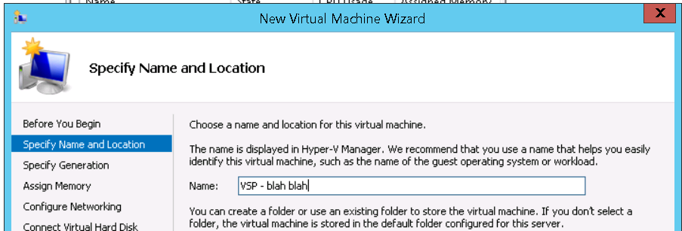

I used Generation 1, seems to work fine;

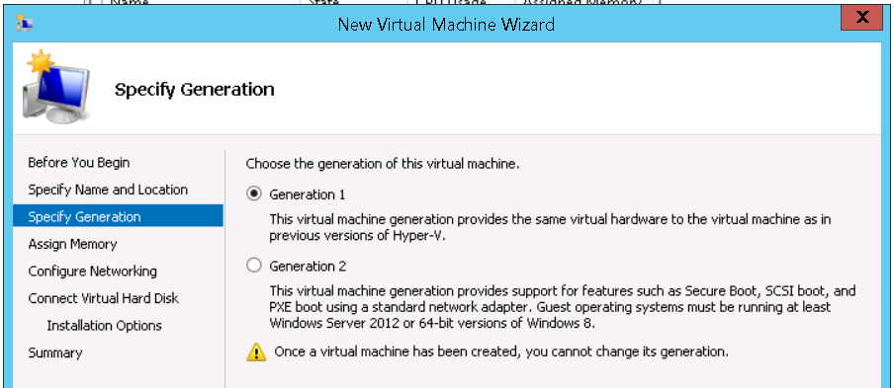

Set memory to 1024MB

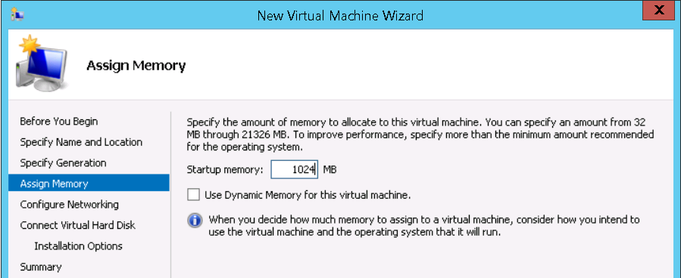

Don’t worry about the network at this time;

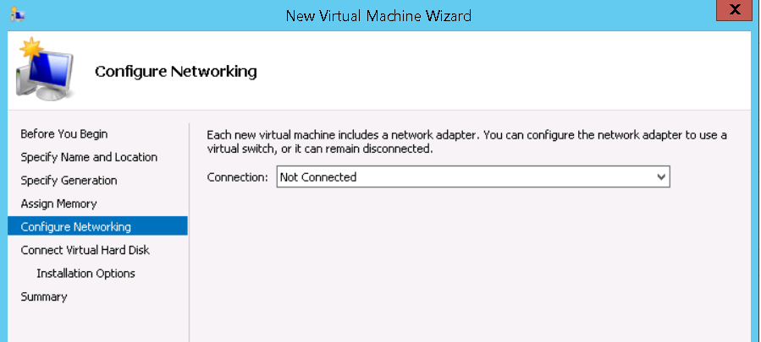

Attach a virtual hard disk later;

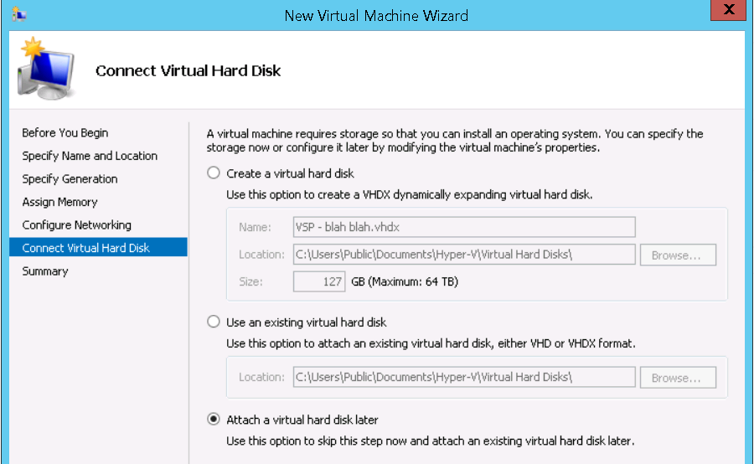

Finish;

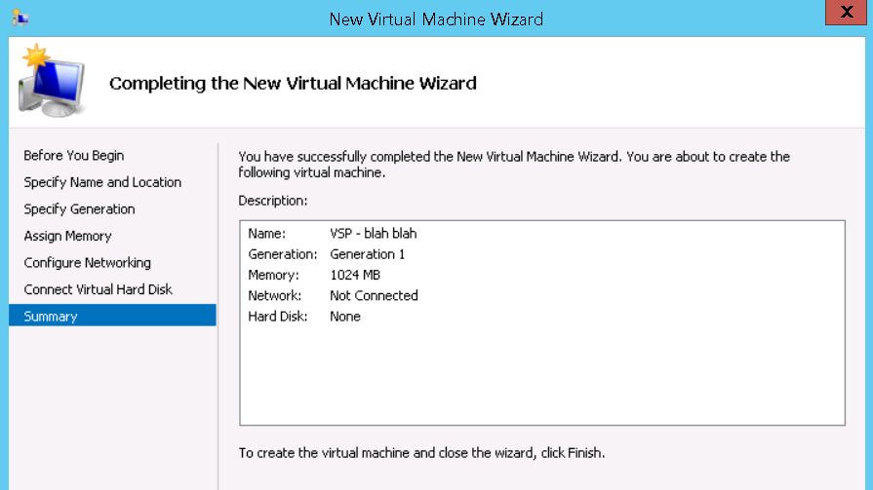

Now we need to edit the virtual machine settings;

Add (2) Legacy Network Adapters

Connect the virtual hard disks

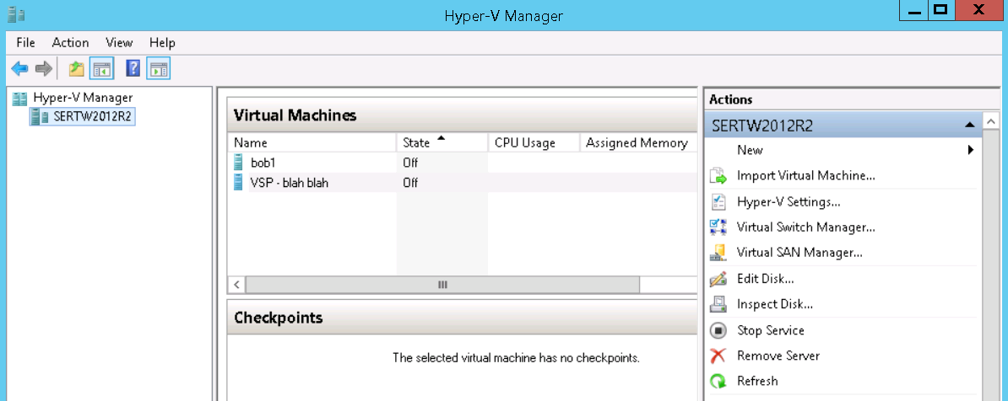

Add Legacy Network Adapters, make sure to select the proper virtual switch definition for your situation. Mine is “New Virtual Switch.” This is important for the first Legacy Network Adapter, as this is the public interface. 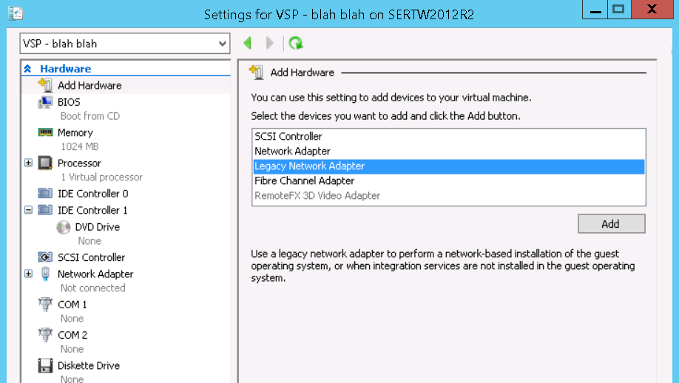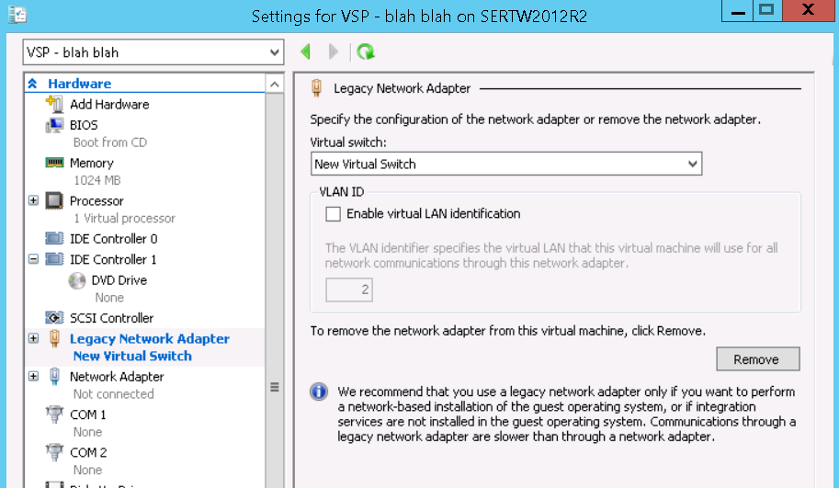

I leave the second Legacy Network Adapter not connected.

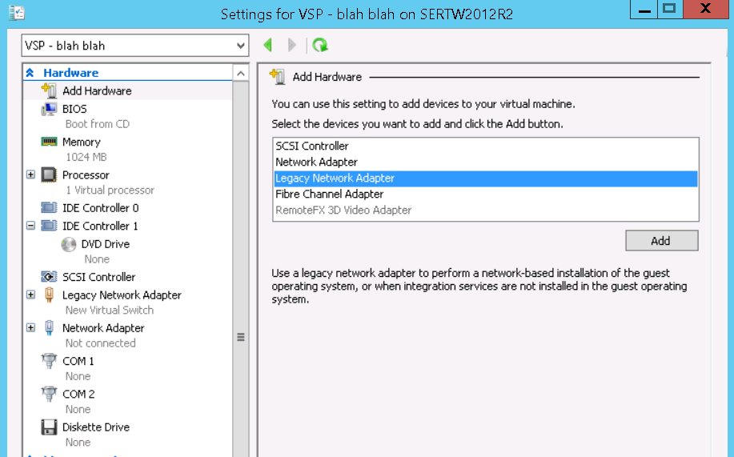 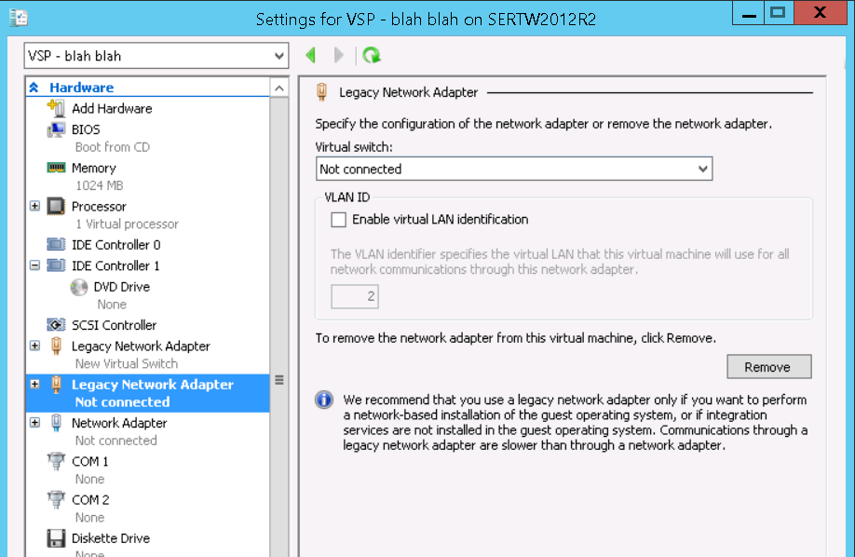

Connect the Virtual Hard Disks;

Select IDE Controller 0 – Hard Drive, then Add

Navigate to the location where you previously copied the VHD files using the Browse button. Connect the -1 VHD first as it’s the boot device.

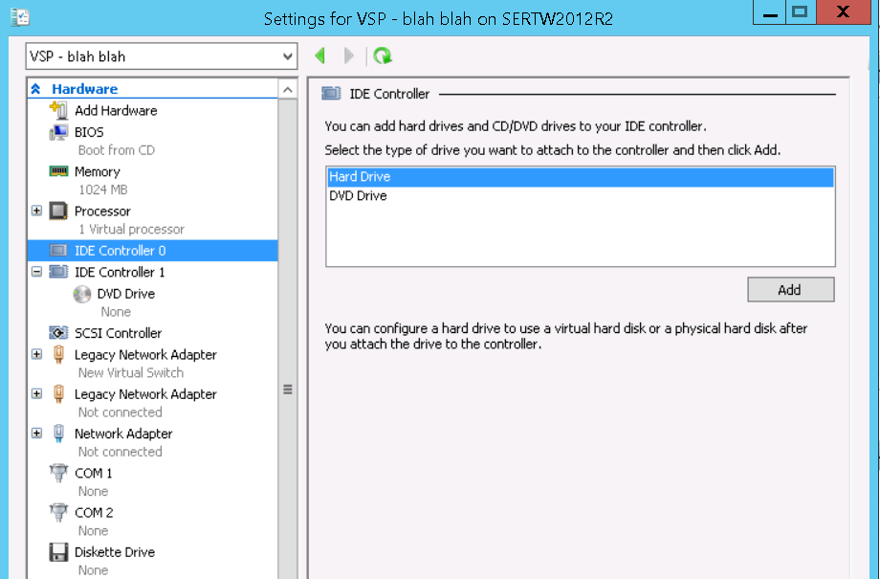 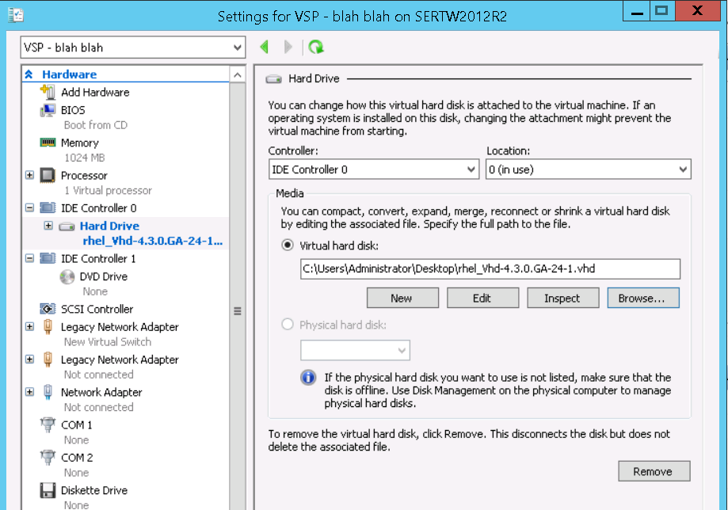

Now the second VHD…

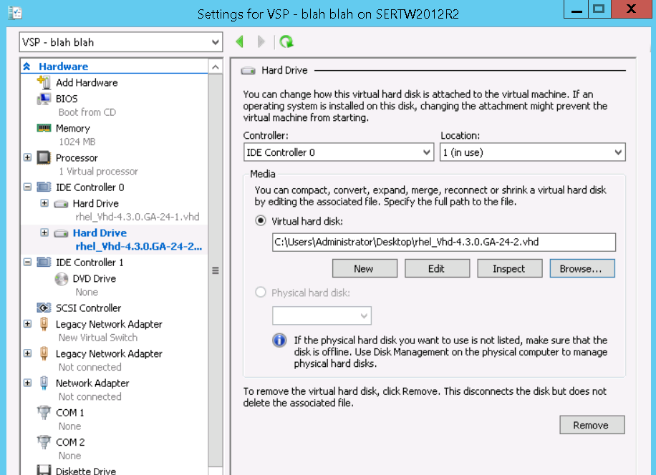

That’s it for the configuration. The VSP should boot and we should have connectivity…

